AGV Web Server User Stories
CTI One Corporation Confidential Information
Kathy Luo

Date | Description | Note
2018-31-01 | User stories for AGV site, color picker page | Kathy Luo

- OVERVIEW
Functions Available:
As an operator I want to upload a picture of my warehouse, click an appropriate image area, and select from a ranked list of colors based on that image area
so that I have the optimal algorithm for my applications.
General functions to be implemented:
- Image can be uploaded
- Uploaded image can be clicked to define an image area
- Ranked list of colors will be shown after image area selection
- Colors from ranked list can be selected

II. DETAILED USER STORIES

- Identify the Page:
As an operator using the site,
I want to be able to identify the purpose of the page easily
so that I can verify I am at the correct location.
Completion Criteria:
  - Clear title and sub-headers
  - Company logo displayed on the top left

- Tap-friendly Interface:
As a mobile or tablet user,
I want to tap through the interface easily
so that I can finish setup in one smooth motion.
Completion Criteria:

  - Have a clear flow of user tasks from up to down
  - Have mobile-friendly click events and views

- Vertical View Friendly Interface:
As a mobile or tablet user,
I want to identify the next step immediately
so I can finish the task in order easily
Completion Criteria:
  - Have a clear flow of user tasks from up to down for mobile and vertical tablet devices

- Clear Flow of Logic:
As a laptop user,
I want to identify the next step immediately
so I can finish the task in order easily.
Completion Criteria:
  - Have a clear flow of user tasks from left to right for laptop and horizontal tablet devices

- Upload Progress:
As a webpage user,
I want to know if anything goes wrong during the upload process
so that I can refresh and try again.
Completion Criteria:
  - Have a progress bar for uploads

- Algorithm Status:
As a webpage user,
I want to know if the algorithm is progressing if I do not see ranked colors being displayed
so that I can restart the process.
Completion Criteria:
  - Have a spinner or signal that the color optimizer is running and not complete

- Ranked Colors:
As an uninformed operator,
I want to be able to easily choose the best available color
so that I can optimize my operations easily.
Completion Criteria:
  - Have a ranked list of colors to select from

- Confirmation Box:
As an error-prone user,
I want to select the correct color and be able to confirm my selection
so that I can avoid operator error.
Completion Criteria:
  - Have a confirmation screen displaying the color and rank

III. APPENDIX

Contents:
- Figure 1. Meeting Notes
- Figure 2. Wireframe
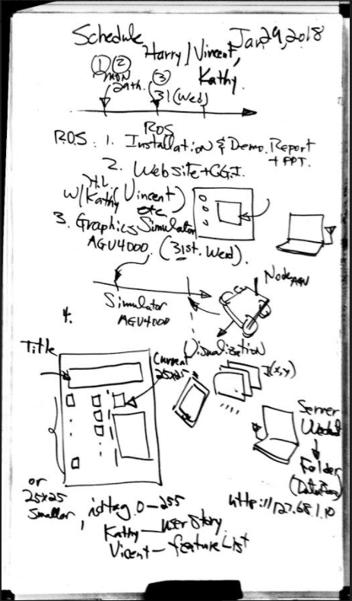

Figure 1. Meeting notes for Jan 29th, 2018. Meeting on Color Picker and ROS features of AGV site.

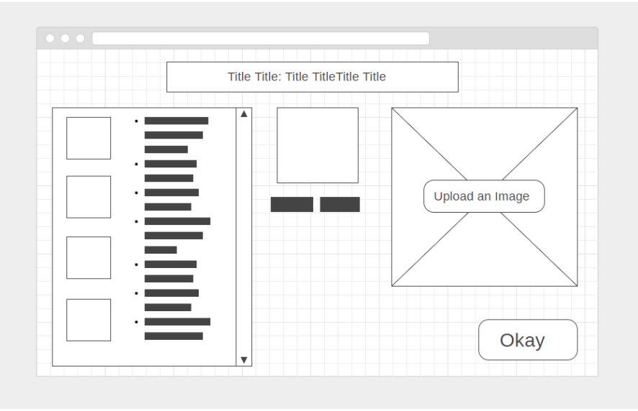
Figure 2. Preliminary wireframe for laptop view

