TX2 Cloning Procedure Documentation
CTI One Corporation Confidential Information
Kathy Luo

Date | Description | Note
2018-02-09 | Instructions for the cloning of Nvidia Jetson TX2 environment published February 9th 2018. | Kathy Luo

- OVERVIEW

This document details the steps needed to clone a Jetson TX2 Module (TX2) environment to a new Jetson TX2 Module.

- PREREQUISITES

There are several prerequisites to this tutorial. Please have the following setup and materials available:

- A computer with Ubuntu 14.04 or 16.04 and 28 GB of free space. This will be the host computer.
- The host computer must have native Ubuntu; it cannot be in a VM.
- The host computer must have JetPack L4T installed with Jetson TX2 support. Please refer to the Nvidia Developer site for the relevant packages and steps. A link is available in the Appendix.
- Nvidia micro-USB B to USB cable. The vendor provided cable must be used.
- A TX2 installed with all relevant software and completely setup.
- Any TX2's that must be setup.

II. JETSON TX2 CLONING STEPS

- Ensure all prerequisites are met. Use an Ubuntu laptop or desktop with JetPack already installed and 28 GB of free space.

- Connect the vendor specific cable from the TX2 to the host laptop.

- Put the TX2 into recovery mode:

  - Make sure the TX2 is powered on.
  - Hold down the REC button (REC refers to recovery, and it is next to power button)
  - While REC is held down, press RES reset once, wait a sec and let go of REC

- On your own laptop, check that the TX2 is in recovery mode using lsub in the terminal.
$ lsusb

- One of the buses will list an item from Nvidia. If it isn’t showing up, make sure:
  - you are not using an Ubuntu VM
  - you have the machine in recovery mode
  - you are using the vendor provided micro-USB B to USB cable.

- On the host computer, go to where you have installed JetPack L4T and into the Tegra for Linux TX2 folder. Alternatively, search for flash.sh and open the folder containing the file.
  - If using someone else’s computer, backup any backup.img and backup.img.raw files.

- While in the Tegra for Linux TX2 directory, run the following to create a backup.img of the connected TX2:

$ sudo ./flash.sh -r -k APP -G backup.img jetson-tx2 mmcblk0p1

- Take the backup.img and rename it as system.img and then move it to the bootloader folder.

- Ensure the backup.img has been renamed and moved and is now bootloader/system.img. This is the system image that will be flashed onto the new TX2.

- Now reset the TX2 you have been cloning from. You have completed the backup step and no longer need this TX2.

- Go to the empty TX2 you plan to clone into. Put it in recovery mode (while powered on, hold down REC, press RES once, then let go of REC) and connect the micro-USB B cable.

- Again, use lsusb in the terminal on the host computer to make sure it is connected.
$ lsusb

- From the same directory as the backup step (Tegra for Linux TX2), run:

$ sudo ./flash.sh -r -k APP jetson-tx2 mmcblk0p1

- The terminal should show a progress bar and percent.

- When the cloning is complete, press RES on the TX2.

- Disconnect the built-in camera on the TX2 by unscrewing the two screws and pulling the camera out gently. See the Appendix items 2 and 3 for reference.

- Reset the TX2 after successfully disconnecting the built-in camera.

- Connect your peripherals and test the system. Make sure you’ve connected the cameras relevant for the setup. See Appendix item 4 for a 40 sign if needed for testing.

- Cloning is complete.

IV. APPENDIX

Contents:
- Nvidia Jetpack website.
- Figure 1. TX2 camera to remove.
- Figure 2. TX2 with camera removed.
- Figure 2. 40 Sign for camera testing.

- Nvidia Jetpack reference available at time of documentation: https://developer.nvidia.com/embedded/jetpack

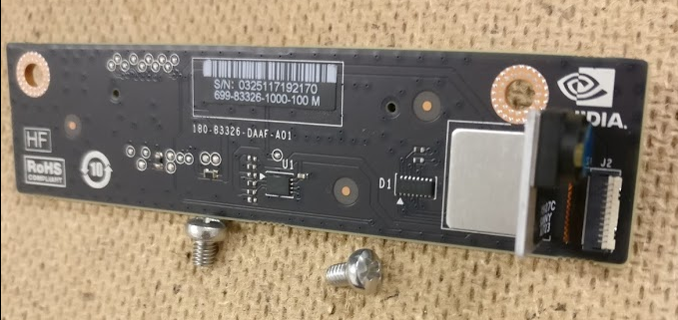
- Figure 1. TX2 built-in camera that needs to be removed.

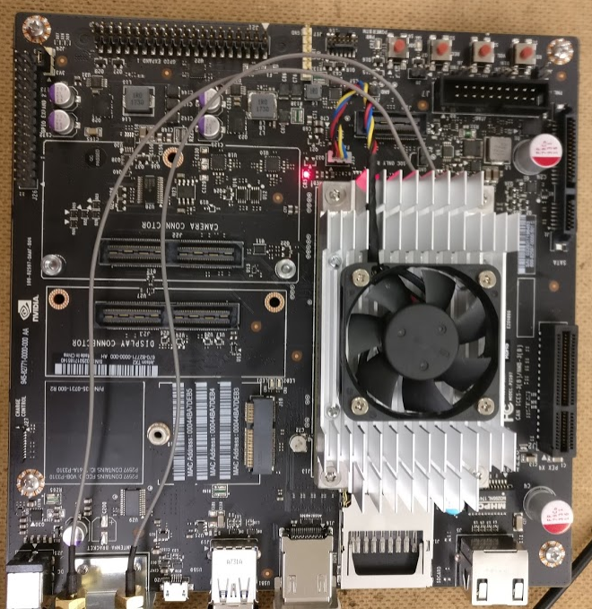
- TX2 with camera removed.

- Figure 3. 40 Sign for use in testing the environment installation.

